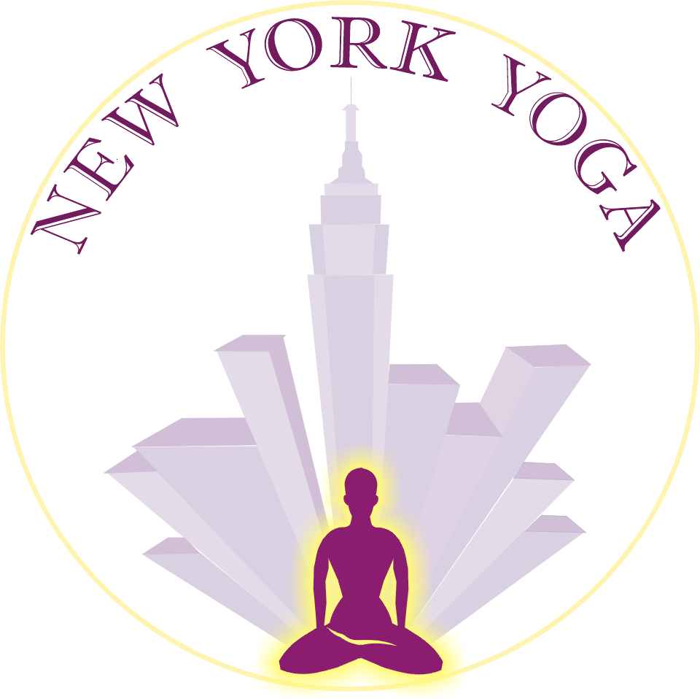

Minor Waiver of Liability

Date: _____________

Permission and Waiver to Participate in Yoga Classes or Workshops Given at New York Yoga for Minor by Parents or Guardian

I _____________________, Parent/Guardian of the minor _______________________ residing at ___________________________________ hereby give permission and consent for the above-mentioned minor, under my full care, to participate in any and all yoga classes or workshops given by New York Yoga. I further understand that the minor mentioned above is subject to all the rules, regulations, and restrictions expressed in the Membership Agreement and/or Waiver of Liability. I have fully read the Membership Agreement and Waiver of Liability.

_______________________________

Parent or Guardian Signature

Note to Parent:

Be advised that this agreement will be invalid unless it is delivered by you to New York Yoga and an unconditional guarantee that you are in fact the minor’s parent or guardian.

_______________________
New York Yoga

